Machine Learning. Jan – May -2022-Lab Project 3-

K means Clustering-

K-Means Clustering is an [Unsupervised Learning algorithm](https://www.javatpoint.com/unsupervised-machine-learning), which groups the unlabeled dataset into different clusters. Here K defines the number of pre-defined clusters that need to be created in the process, as if K=2, there will be two clusters, and for K=3, there will be three clusters, and so on.

It allows us to cluster the data into different groups and a convenient way to discover the categories of groups in the unlabeled dataset on its own without the need for any training.

It is a centroid-based algorithm, where each cluster is associated with a centroid. The main aim of this algorithm is to minimize the sum of distances between the data point and their corresponding clusters.

The algorithm takes the unlabeled dataset as input, divides the dataset into k-number of clusters, and repeats the process until it does not find the best clusters. The value of k should be predetermined in this algorithm.

The k-means [clustering](https://www.javatpoint.com/clustering-in-machine-learning) algorithm mainly performs two tasks:

* Determines the best value for K center points or centroids by an iterative process.
* Assigns each data point to its closest k-center. Those data points which are near to the particular k-center, create a cluster.

Hence each cluster has datapoints with some commonalities, and it is away from other clusters.

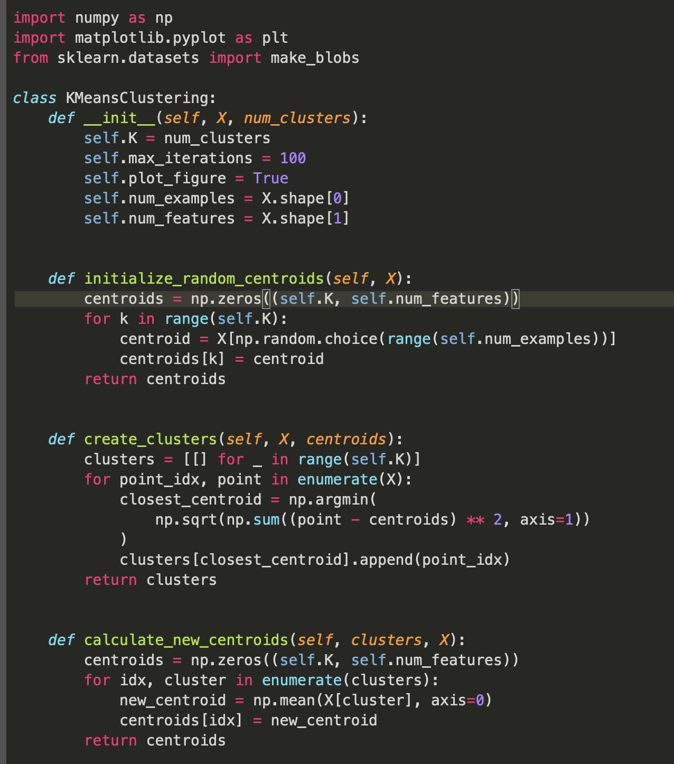

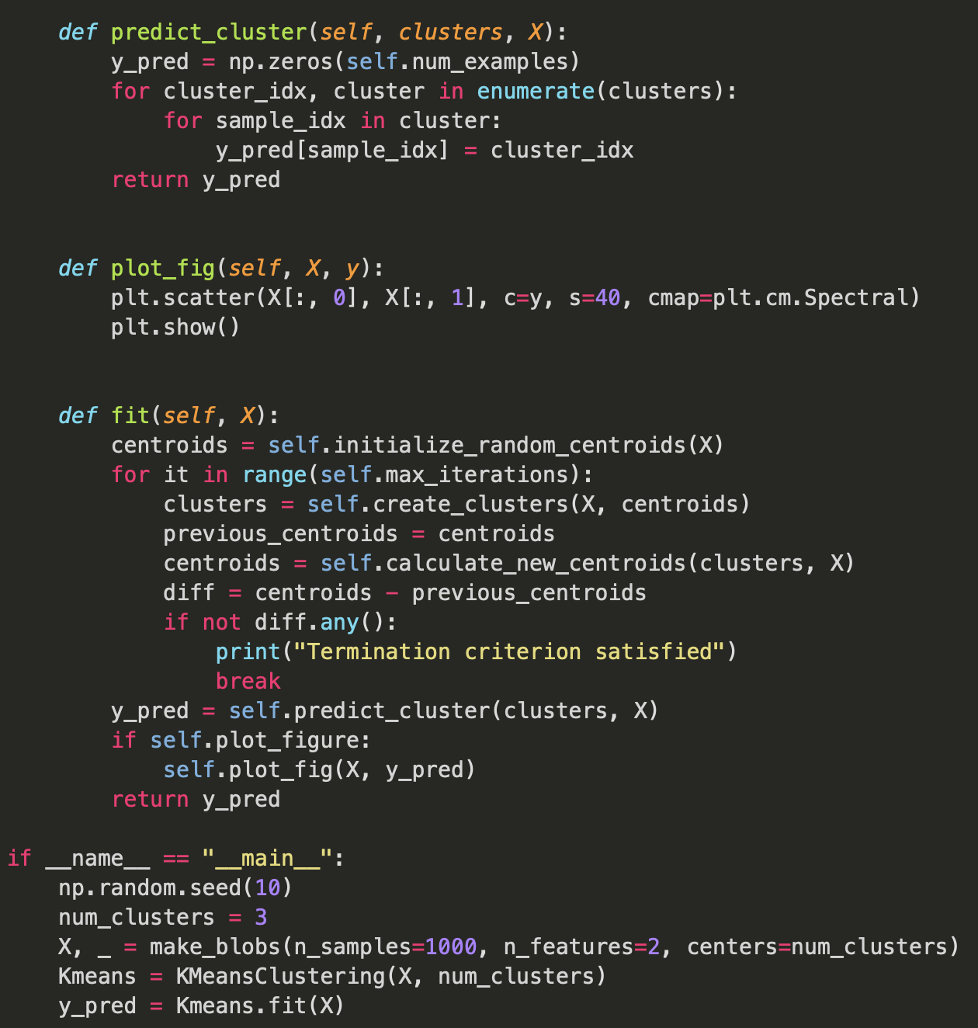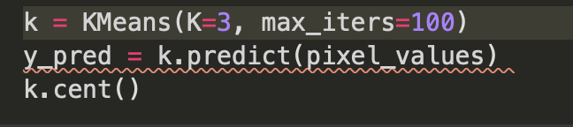

For k=3

Original Image

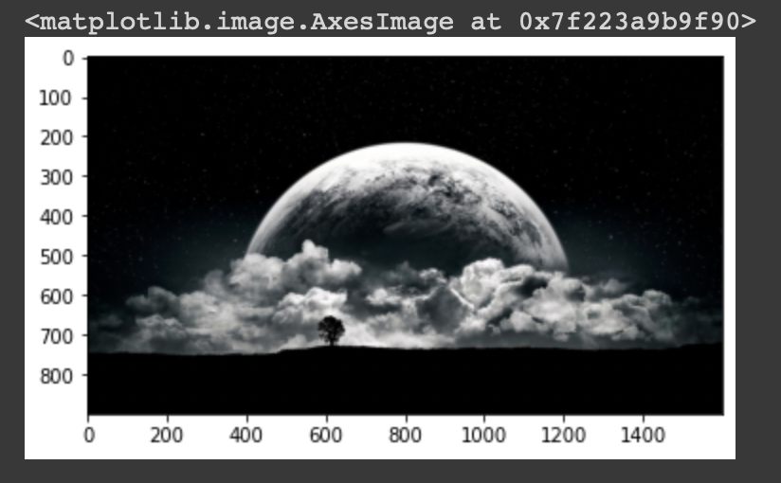

Segmented Image

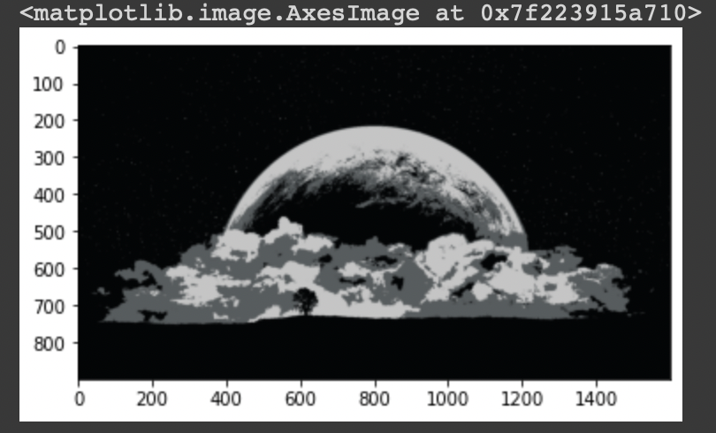

For k=2-

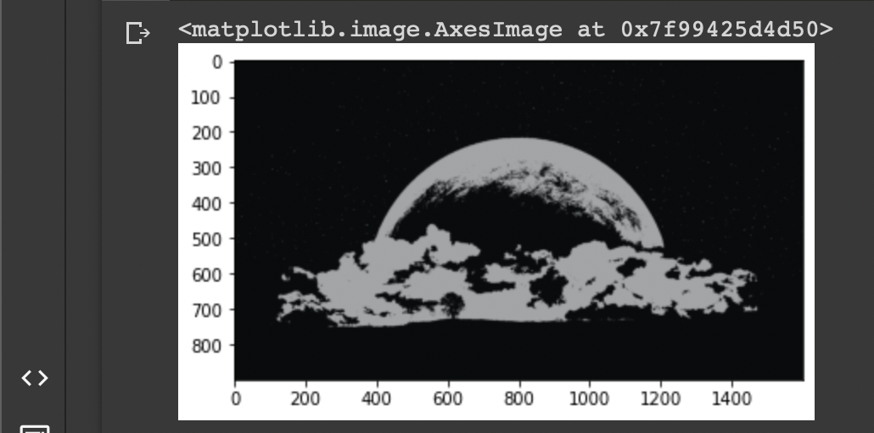

For k=5-

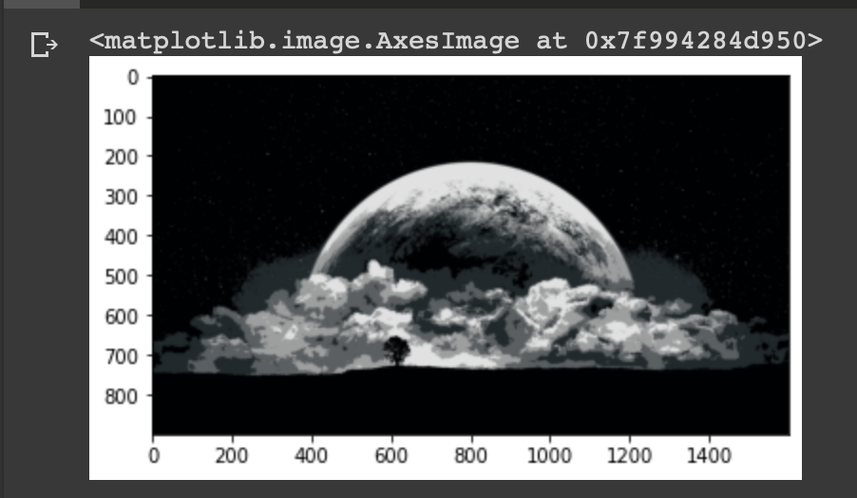

Otsu’s Segmentation-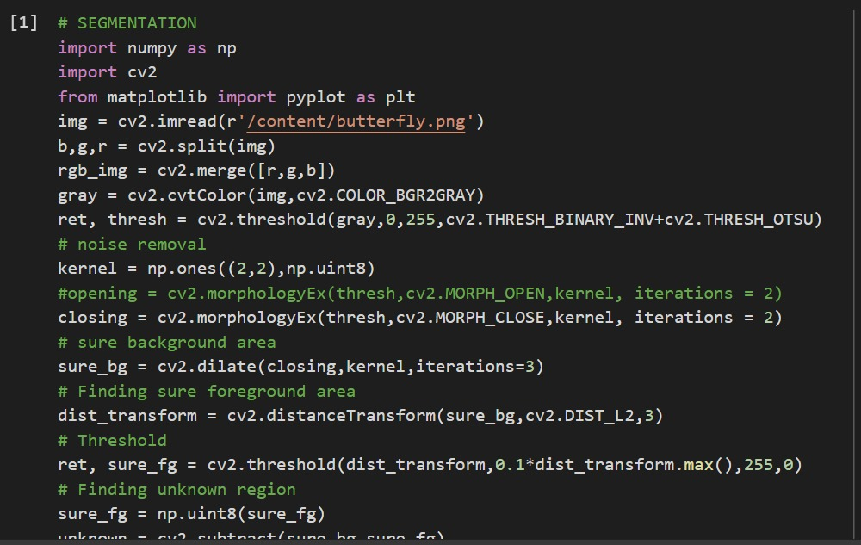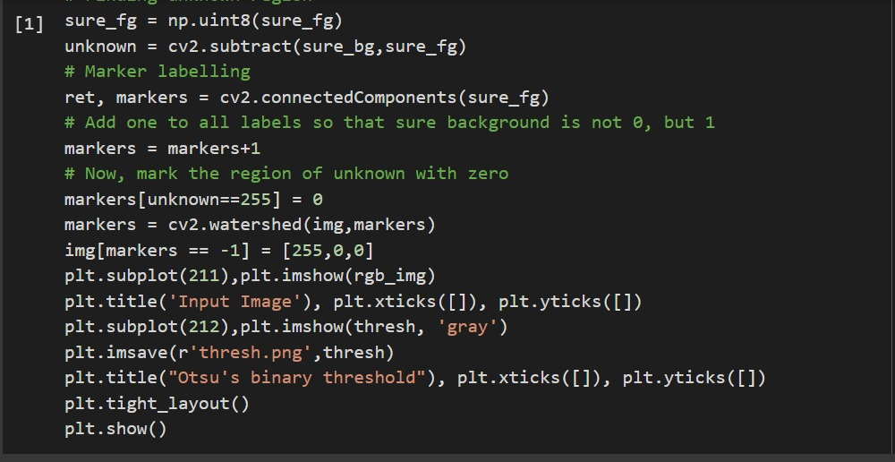

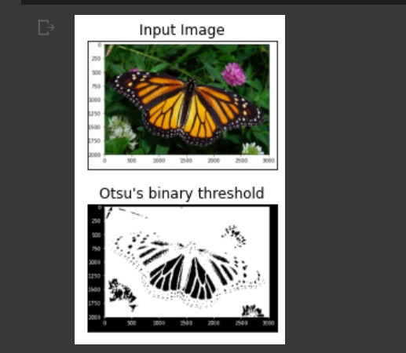

Canny edge detection-

OpenCV puts all the above in single function, **[cv.Canny()](https://docs.opencv.org/4.x/dd/d1a/group__imgproc__feature.html" \l "ga04723e007ed888ddf11d9ba04e2232de" \o "Finds edges in an image using the Canny algorithm  . )**. We will see how to use it. First argument is our input image. Second and third arguments are our minVal and maxVal respectively. Fourth argument is aperture_size. It is the size of Sobel kernel used for find image gradients. By default it is 3. Last argument is L2gradient which specifies the equation for finding gradient magnitude. If it is True, it uses the equation mentioned above which is more accurate, otherwise it uses this function: Edge_Gradient(G)=|Gx|+|Gy|. By default, it is False.

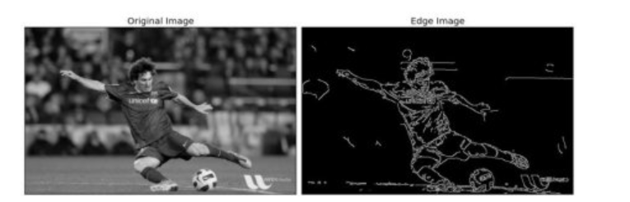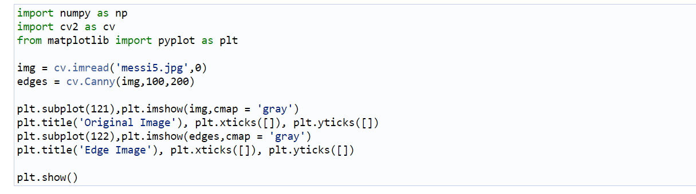

Image segmentation using watershed algorithm-

Any grayscale image can be viewed as a topographic surface where high intensity denotes peaks and hills while low intensity denotes valleys. You start filling every isolated valleys (local minima) with different colored water (labels). As the water rises, depending on the peaks (gradients) nearby, water from different valleys, obviously with different colors will start to merge. To avoid that, you build barriers in the locations where water merges. You continue the work of filling water and building barriers until all the peaks are under water. Then the barriers you created gives you the segmentation result. This is the "philosophy" behind the watershed.

But this approach gives you over segmented result due to noise or any other irregularities in the image. So OpenCV implemented a marker-based watershed algorithm where you specify which are all valley points are to be merged and which are not. It is an interactive image segmentation. What we do is to give different labels for our object we know. Label the region which we are sure of being the foreground or object with one color (or intensity), label the region which we are sure of being background or non-object with another color and finally the region which we are not sure of anything, label it with 0. That is our marker. Then apply watershed algorithm. Then our marker will be updated with the labels we gave, and the boundaries of objects will have a value of -1.

